**Steps to make the apigee-proxy-template functional:-**

1. Clone the git-repo with the below command

🡪 git clone https://github.com/the-singularity-mesh/apigee-proxy-template

1. Move to the master-script folder

🡪 cd master-script

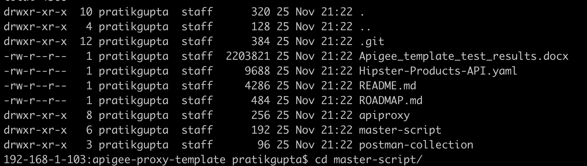

See the contents of it 🡪 ls -al

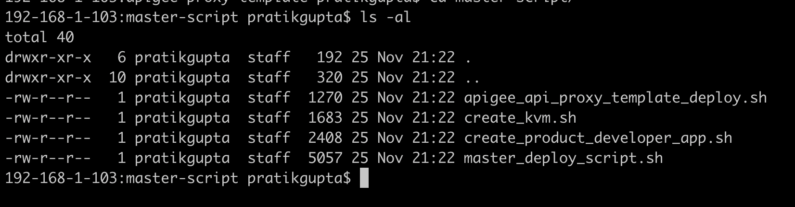

1. Run the master_deploy_script.sh

🡪 sh master_deploy_script.sh

Part 1:- Create KVM config gets executed

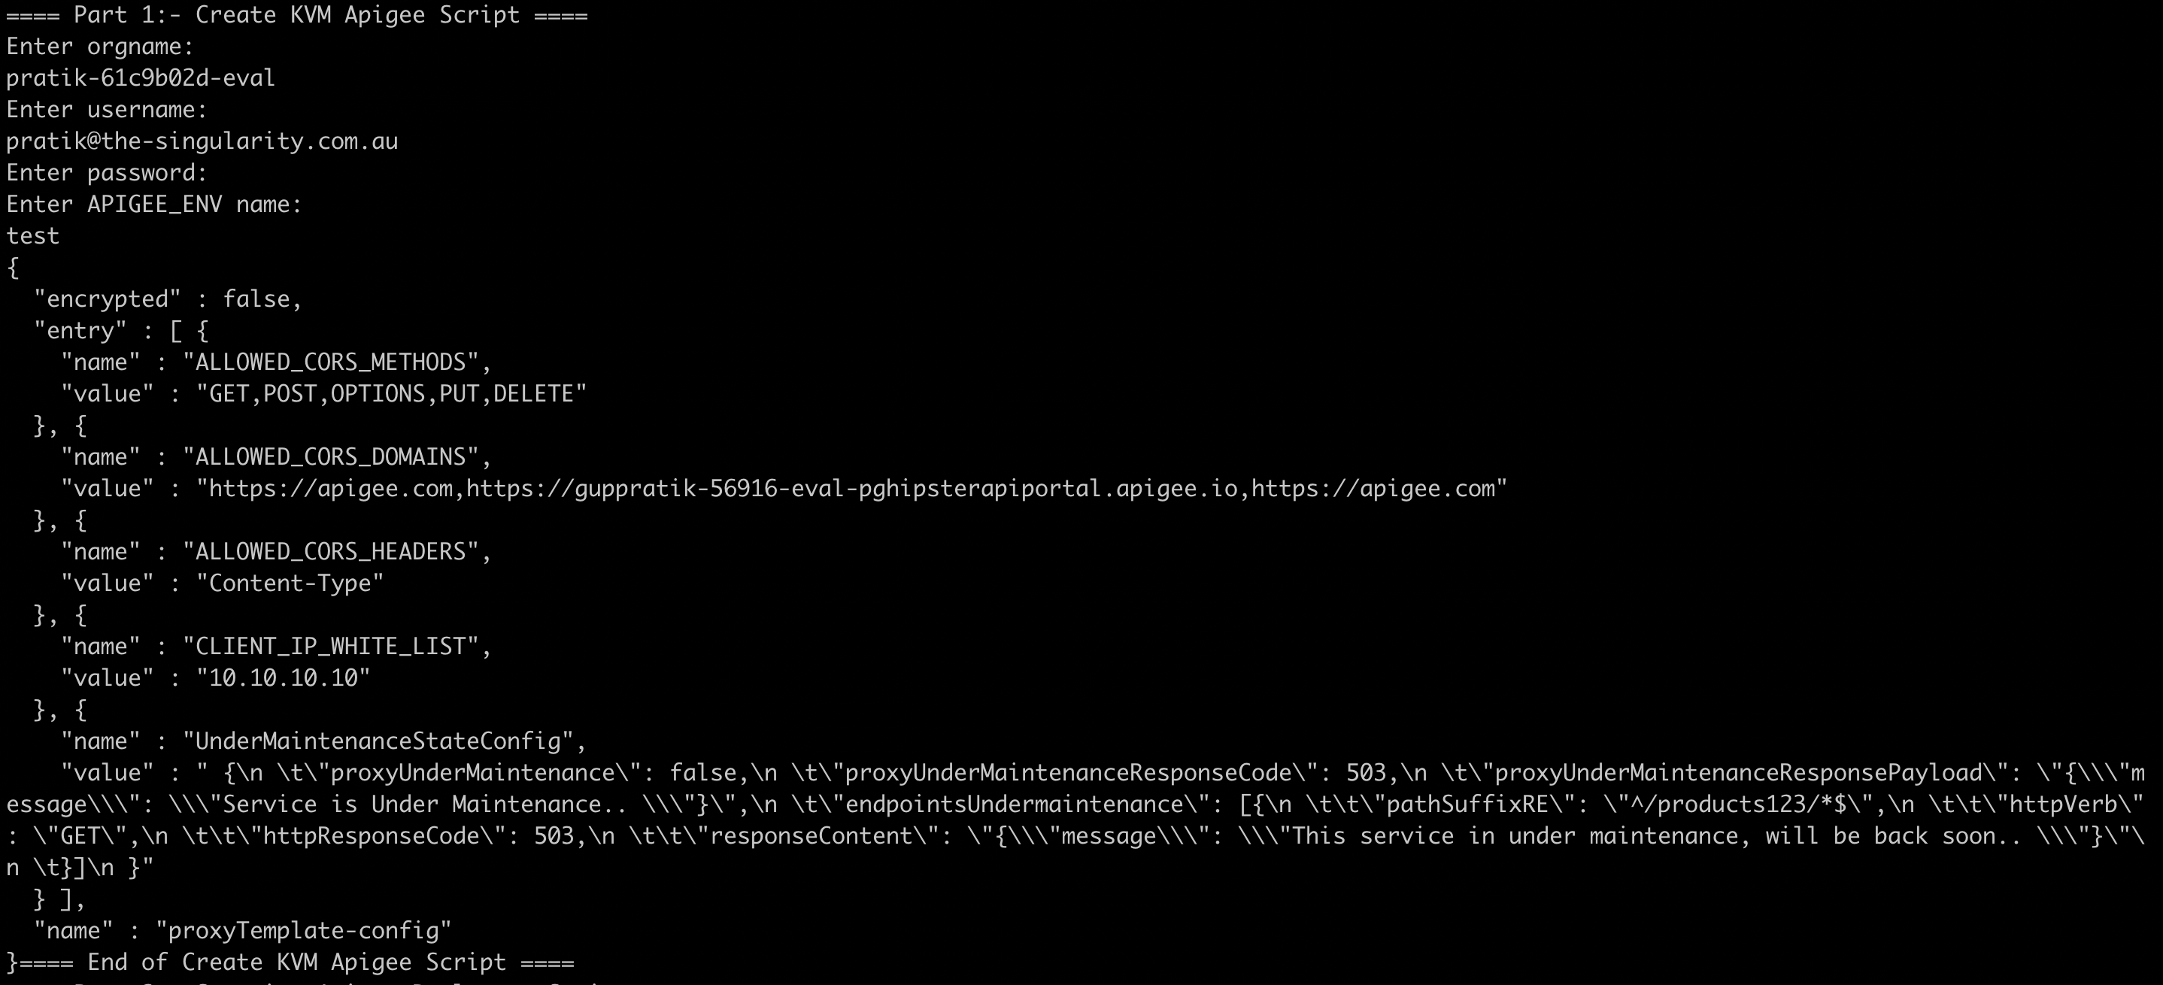

Part 2 :- Download the proxy & deploy the bundle on Apigee

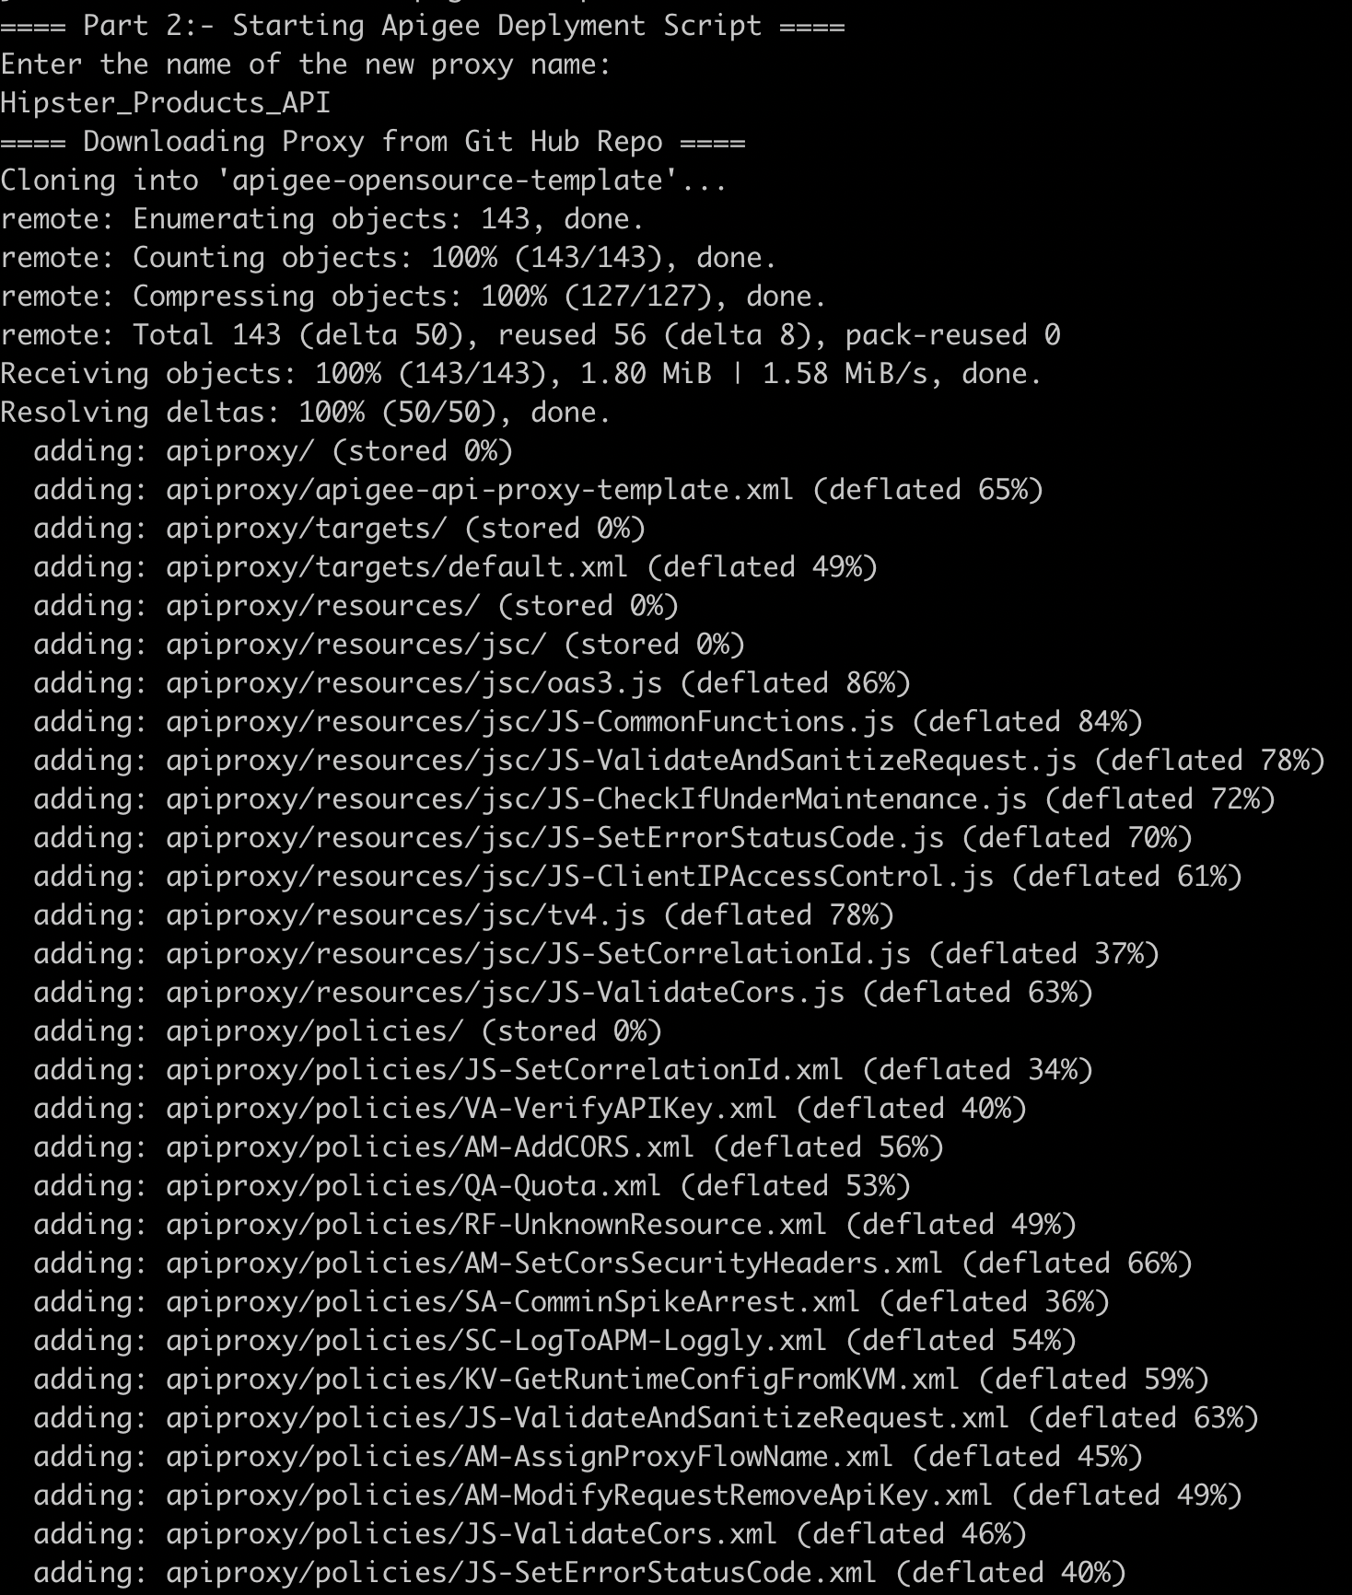

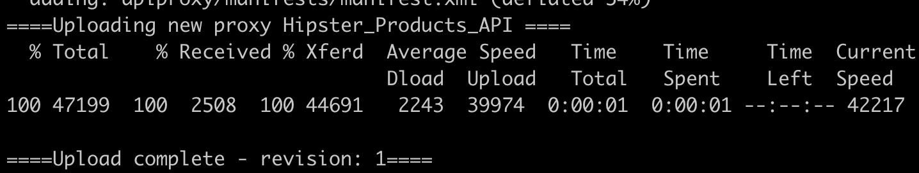

Part 3.1:- Create Product

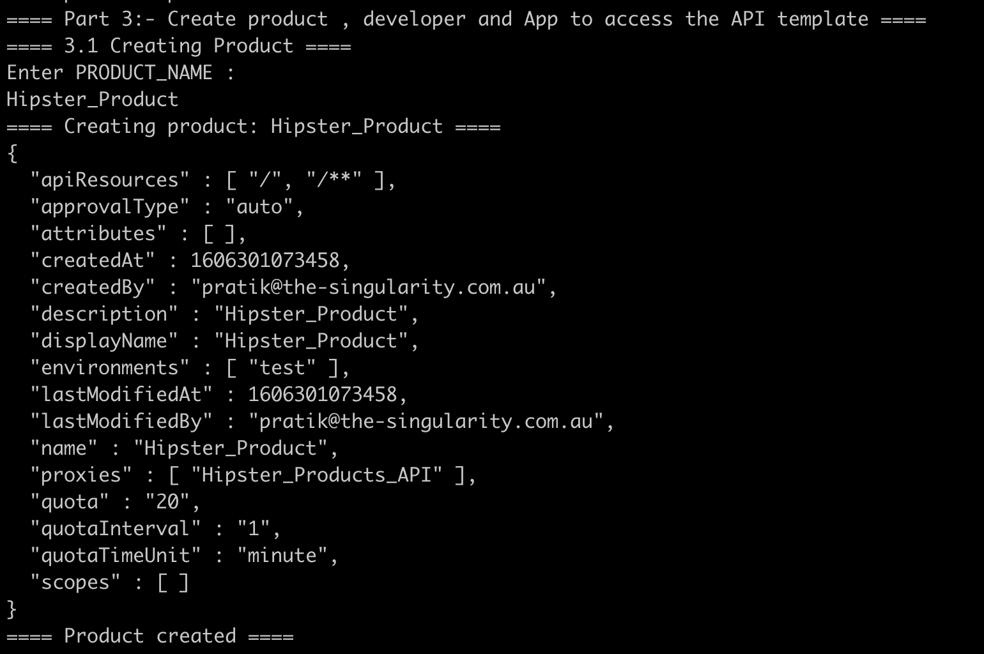

Part 3.2:- Create Developer

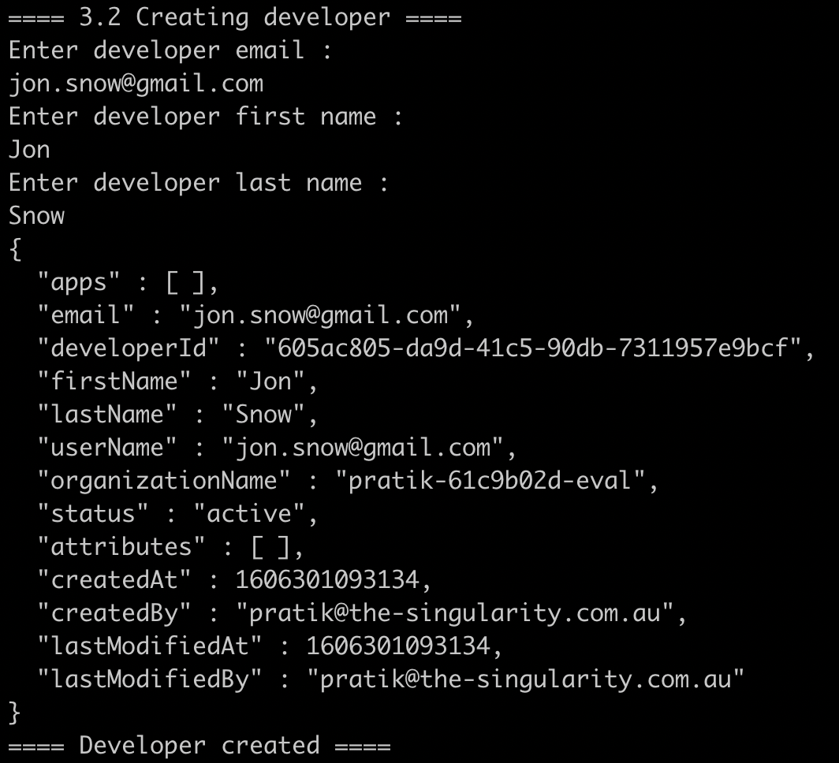

Part 3.3 :- Create an App

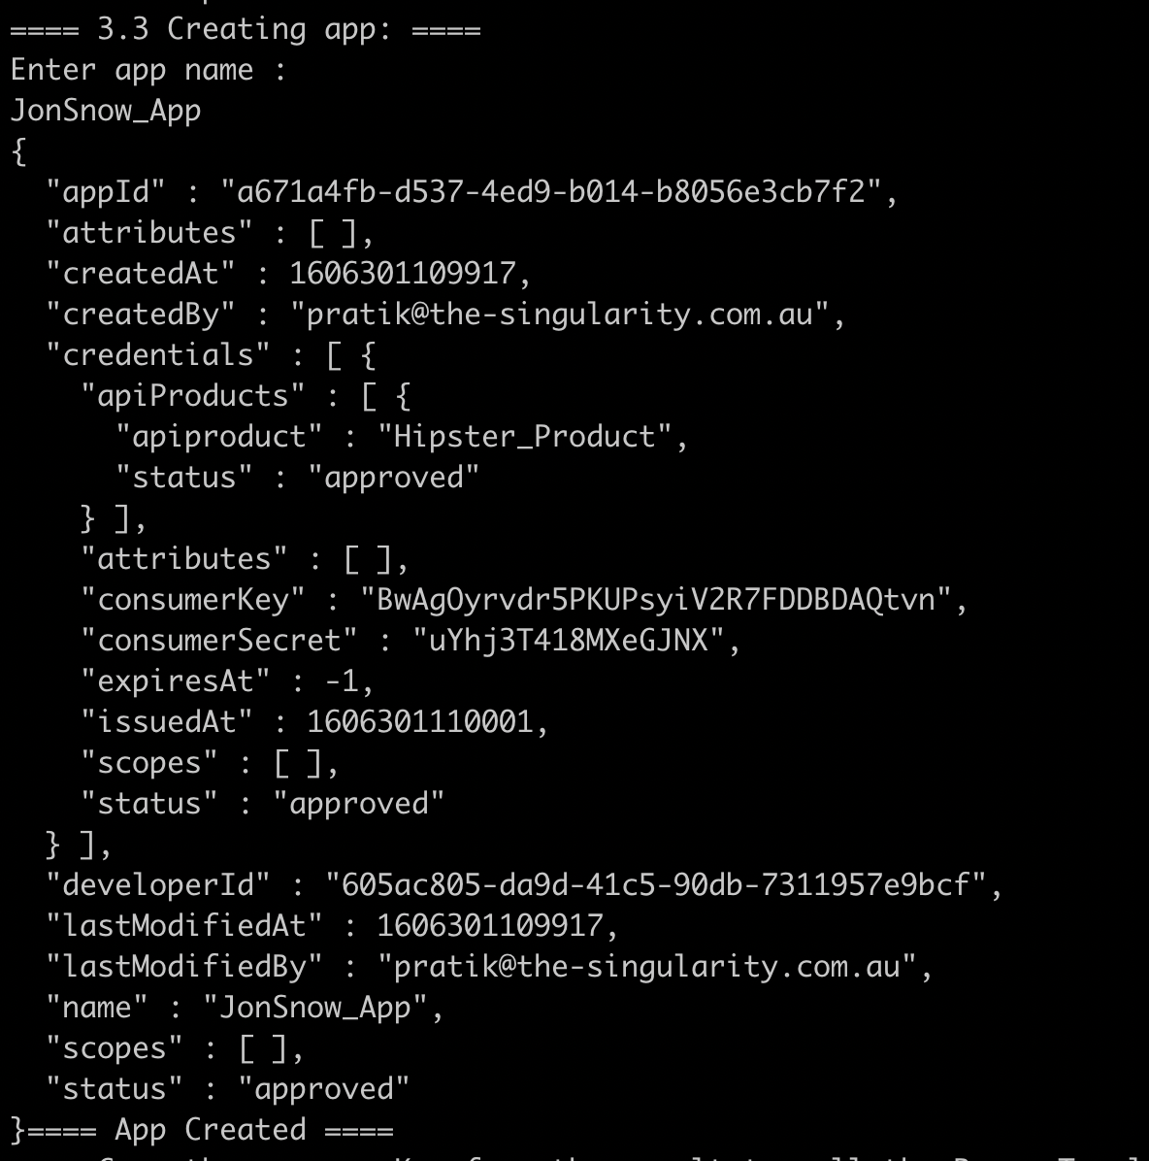

==== Copy the consumerKey from the result to call the Proxy Template API ====

1. Go to the the KVM in the apigee org

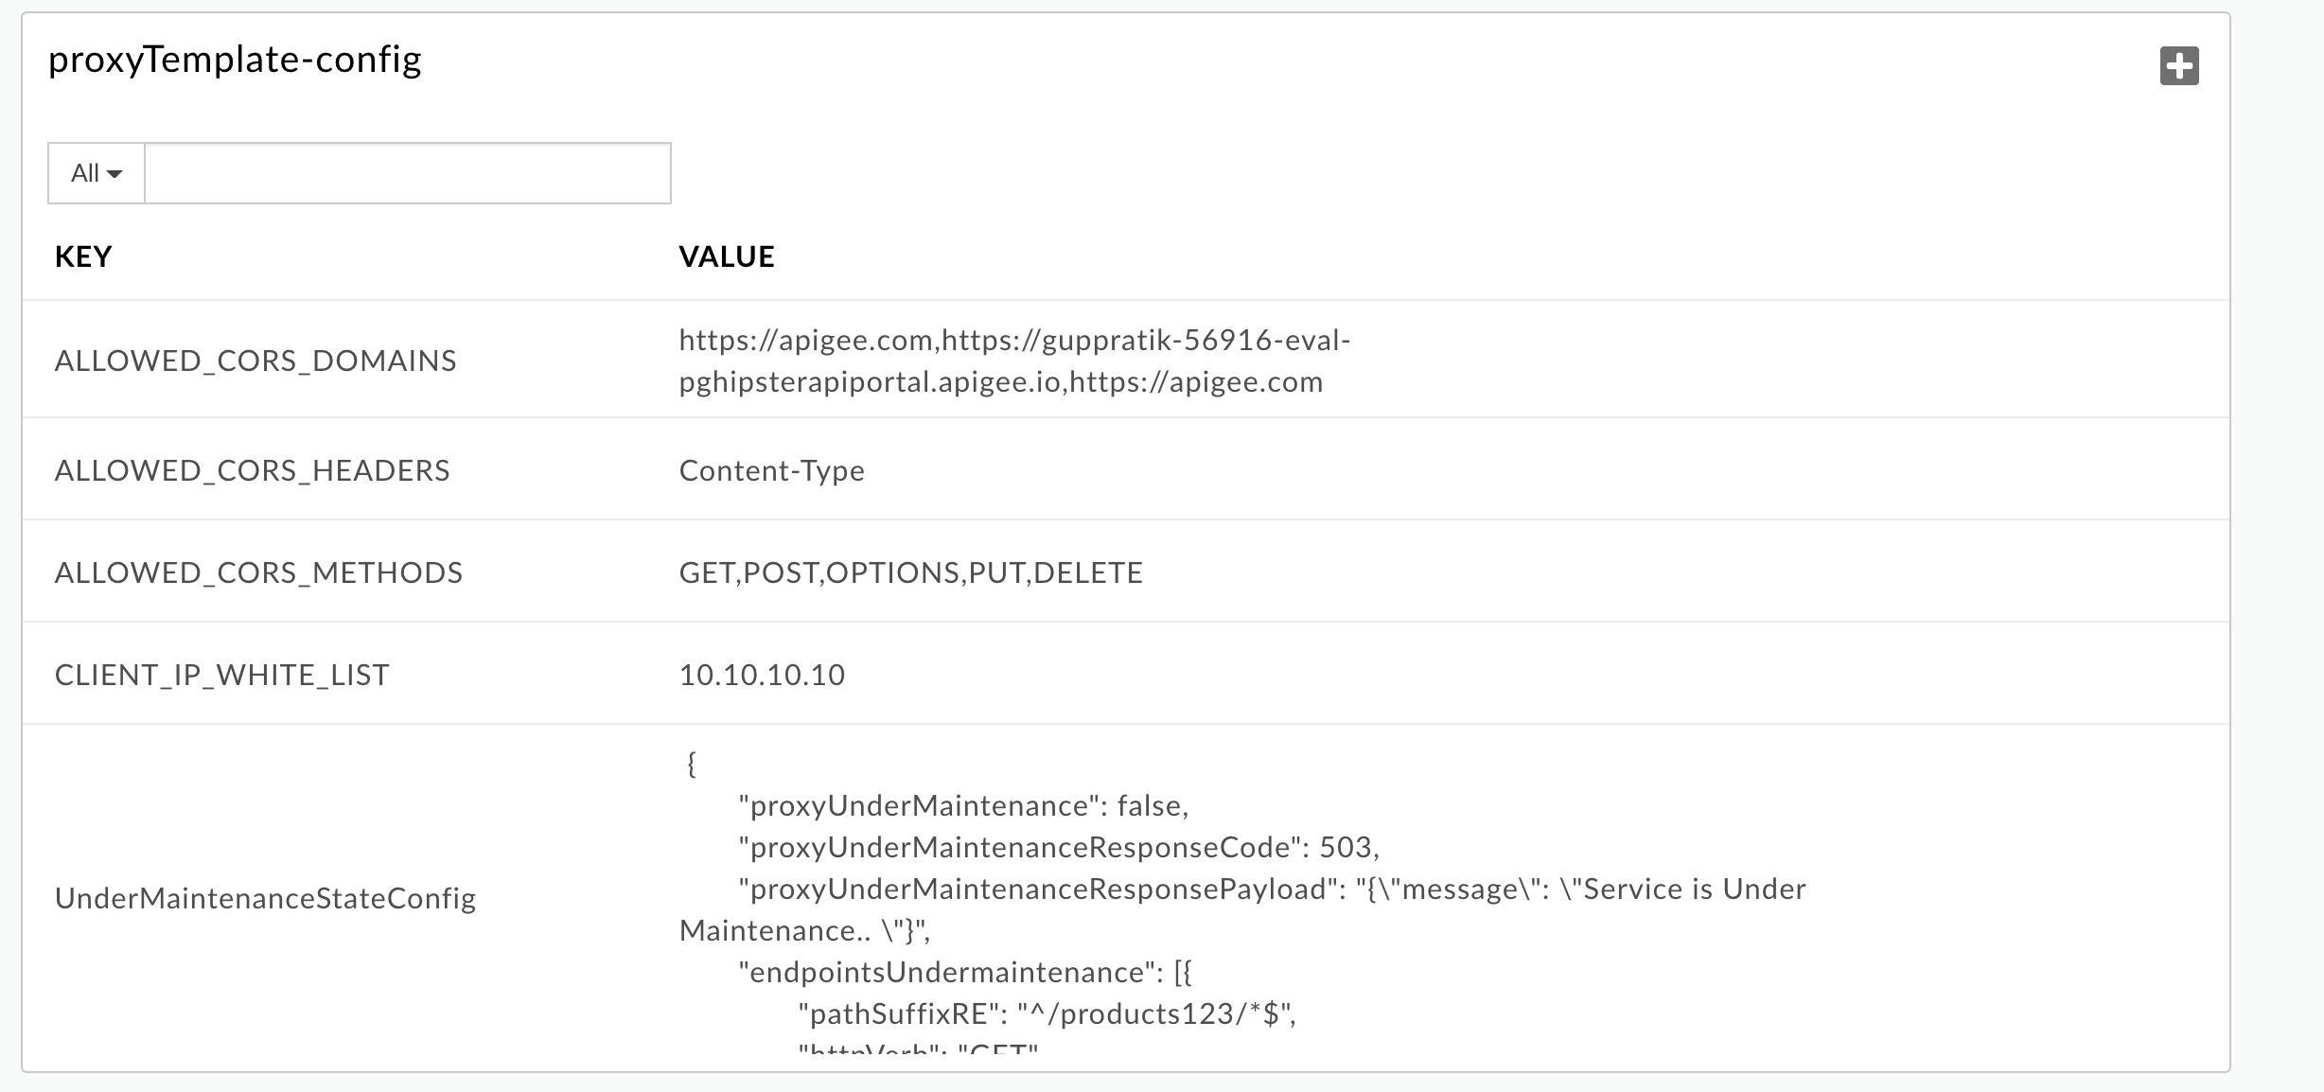

Edit the ALLOWED_CORS_DOMAINS and the domain names from where the request should be allowed to be originated & executed successfully

Add the domain name of the developer portal or/add https://apigee.com from where the request will be invoked

1. In the Apigee Proxies, you can now see the proxy

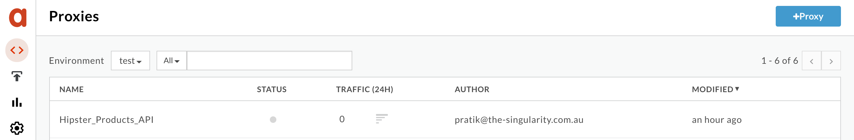

Now click on it and deploy

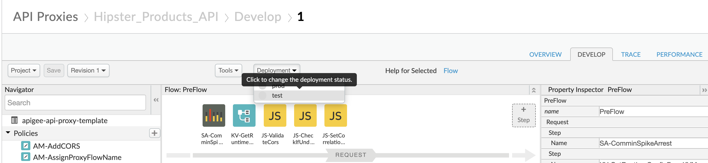

1. Once the revision is deployed , under Resoucres 🡪 jsc 🡪 oas3.js

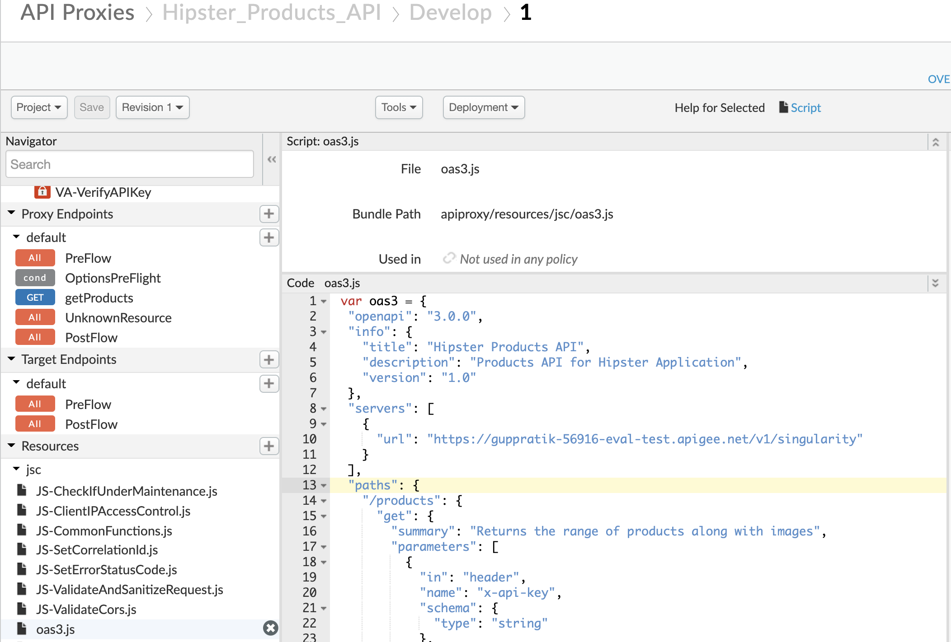

Change the server URL to point it to your own apigee org

**Before :-**

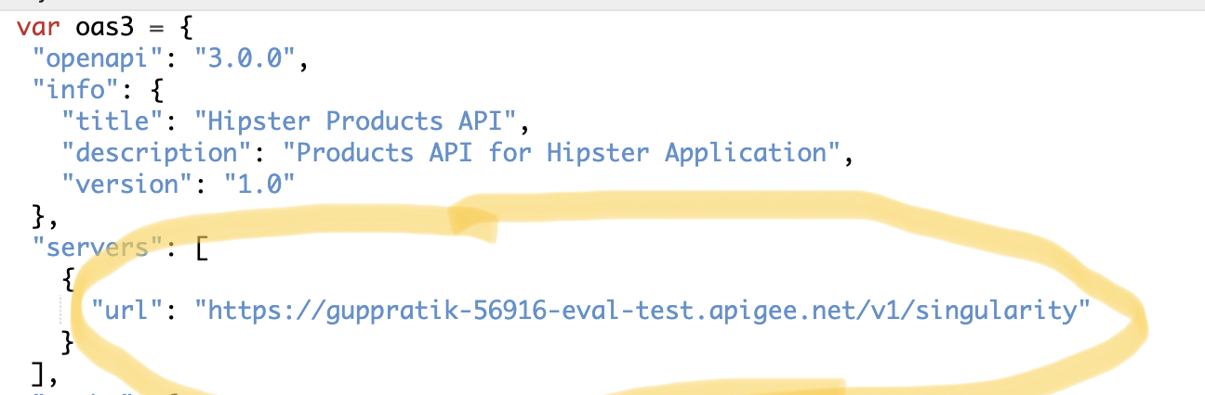

**After:-**

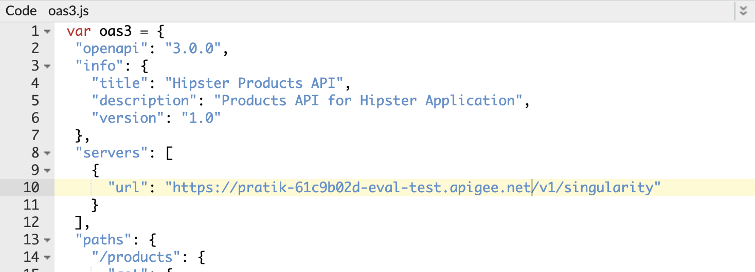

1. Now keep the trace session on to trace the request

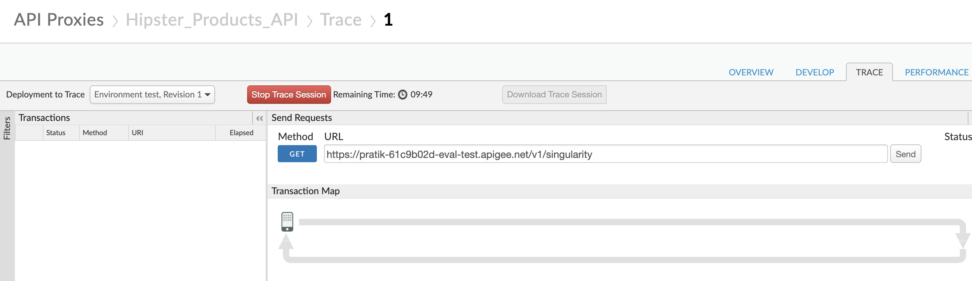

1. Now find the Open API Spec file in your local system that is present in the git repo & import into Apigee Org

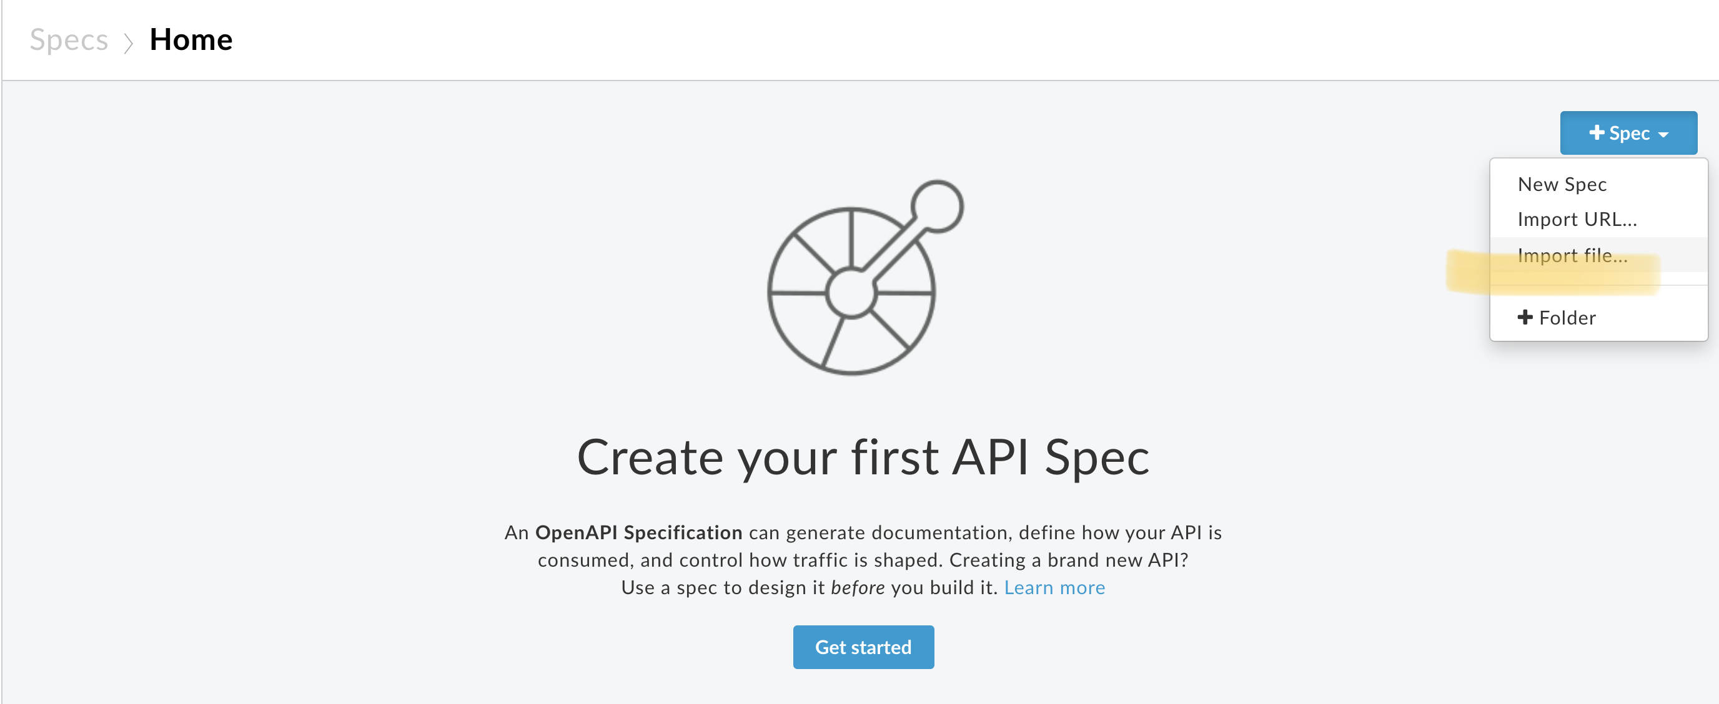

The file gets added successfully

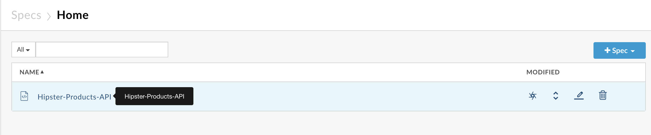

1. Click on the spec and try it out

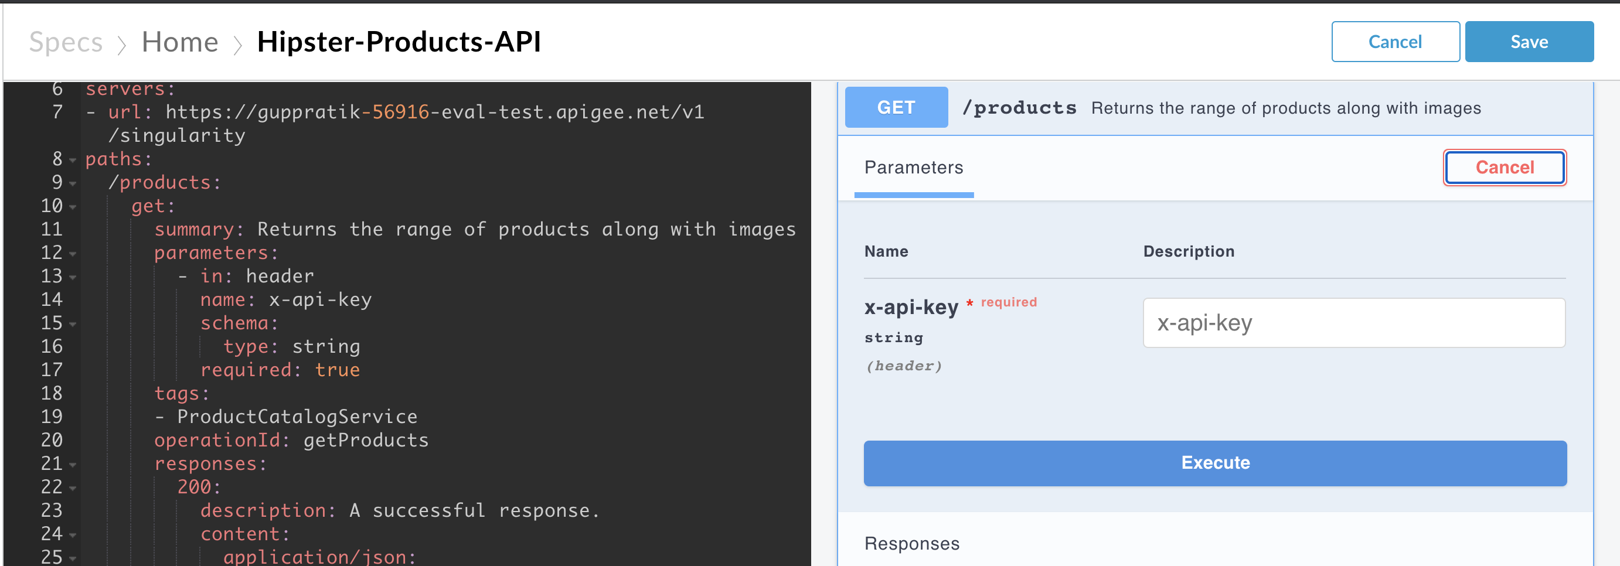

1. Now change the URL to point it to your own org & save the spec once again

**Before**

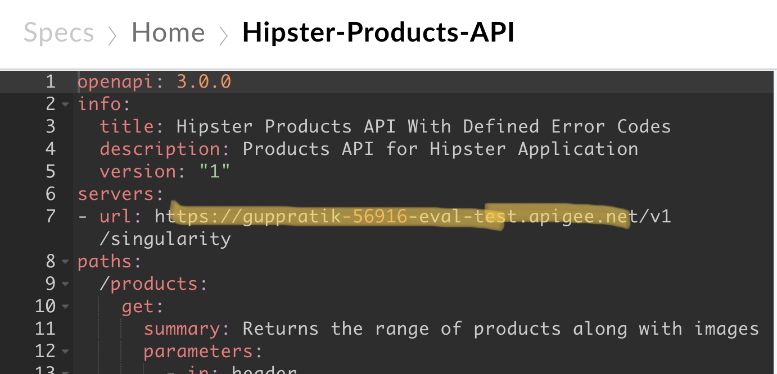

**After**

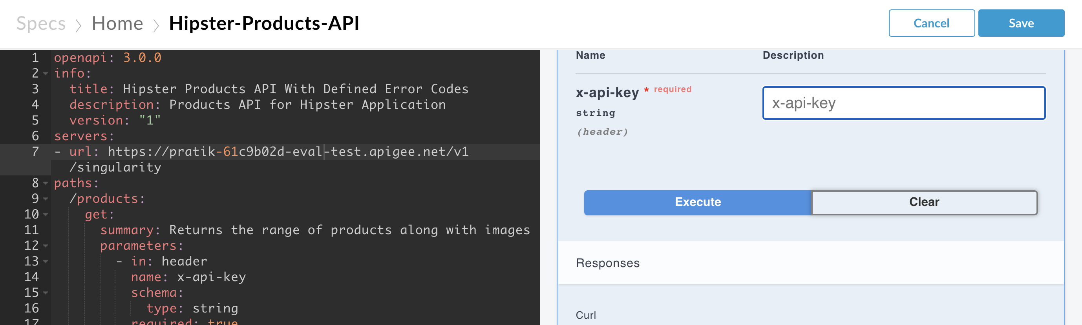

Now copy the consumerKey obtained from Step 3, paste it in x-api-key placeholder and click on Execute

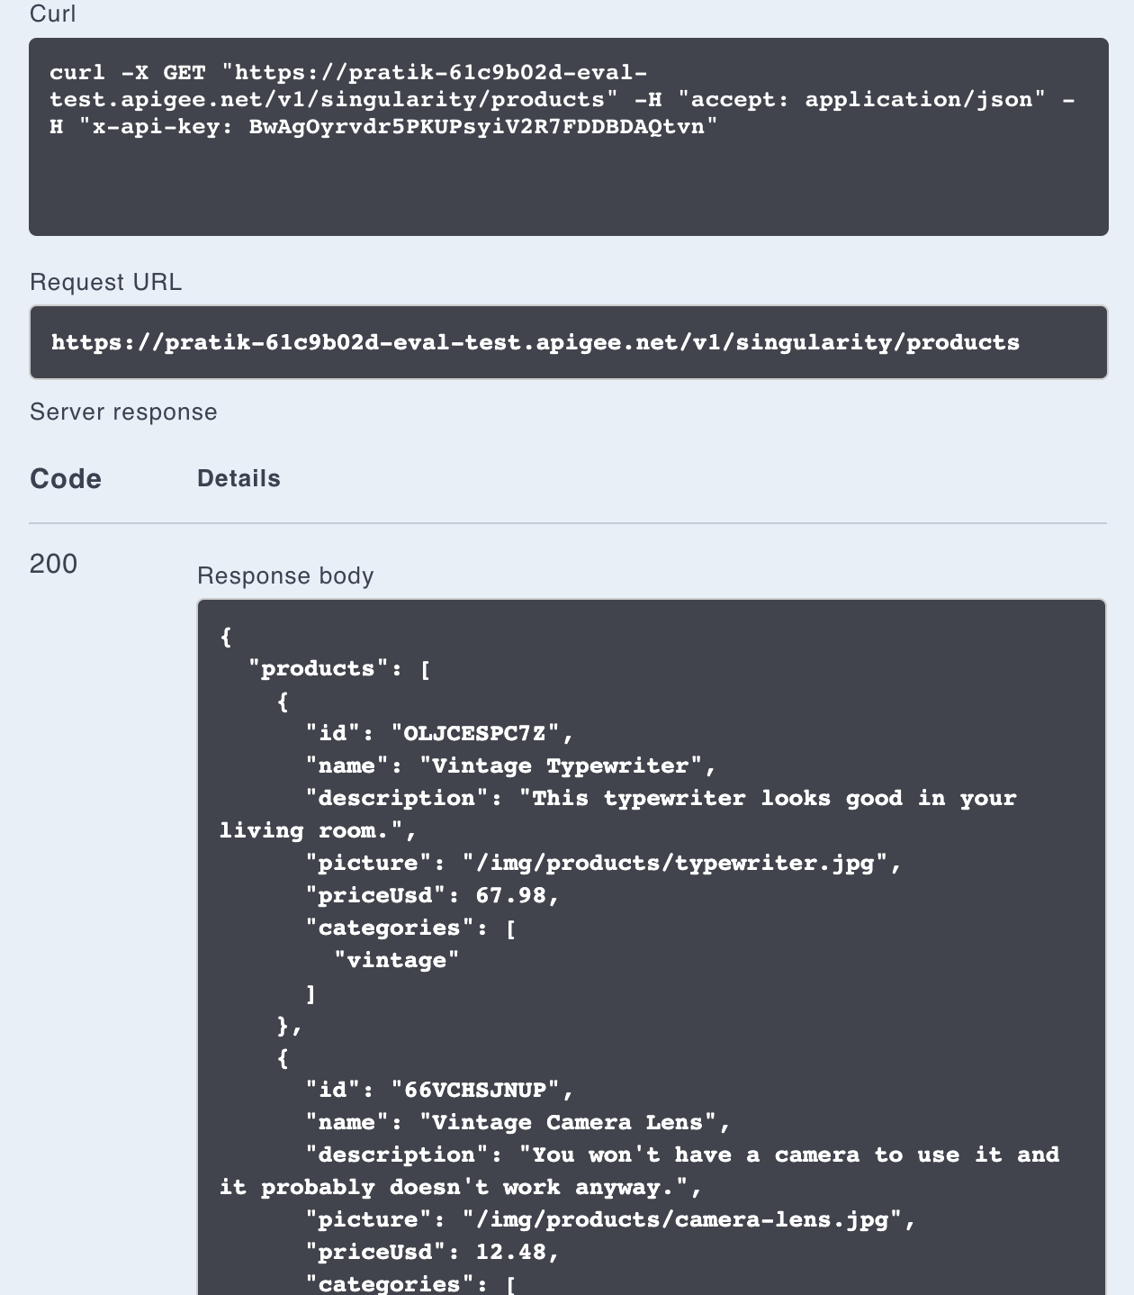

Observe the request & response on Apigee trace

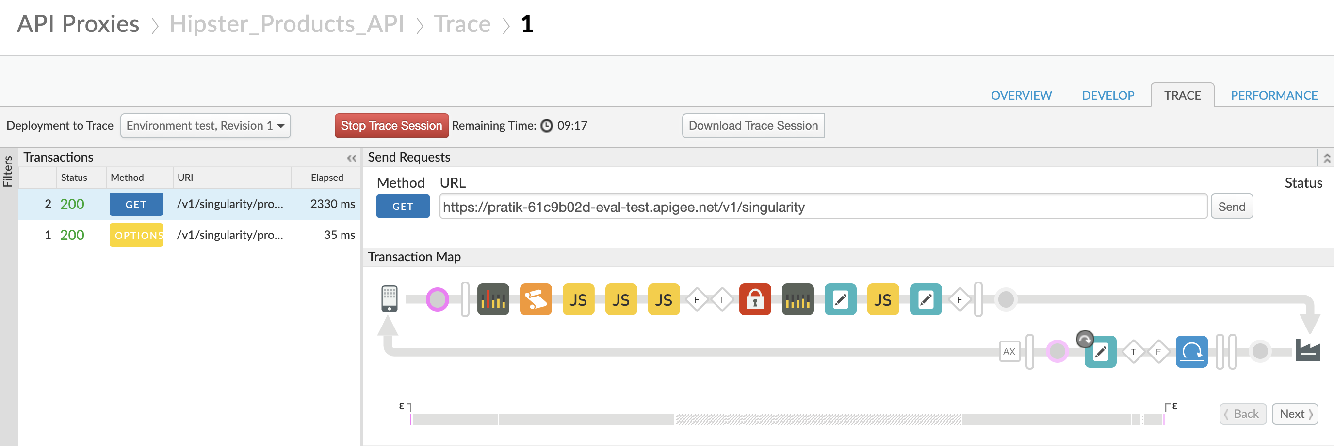

1. Now import the postman collection in postman that is present in the git repo to discover the other functionalities offered by this template

============================**HAPPY EXPLORING**===============================